Hands-on 1: Spring Data JPA - Quick Example

Project Details
Project Name : orm-learn
Group : com.cognizant
Package : com.cognizant.ormlearn
Java : 17
Spring Boot : 3.5.16
Dependencies : Spring Data JPA, MySQL Driver, Spring Boot DevTools
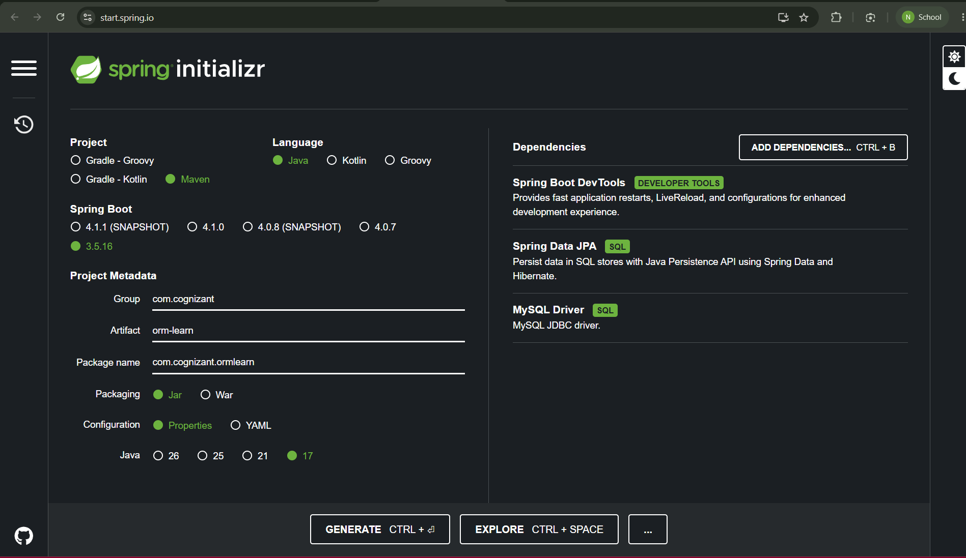

Database Script
CREATE DATABASE ormlearn;
USE ormlearn;
CREATE TABLE country(
co_code VARCHAR(2) PRIMARY KEY,
co_name VARCHAR(50)
);
INSERT INTO country VALUES ('IN','India');
INSERT INTO country VALUES ('US','United States of America');
SELECT * FROM country;
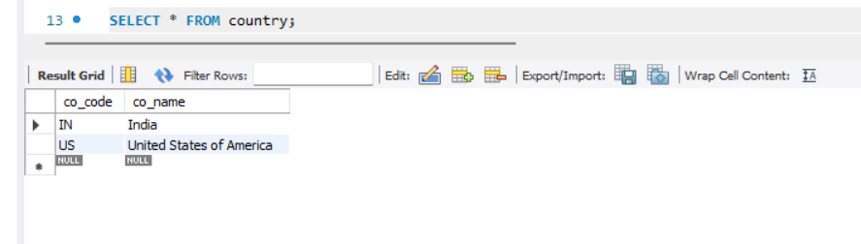

Project Structure
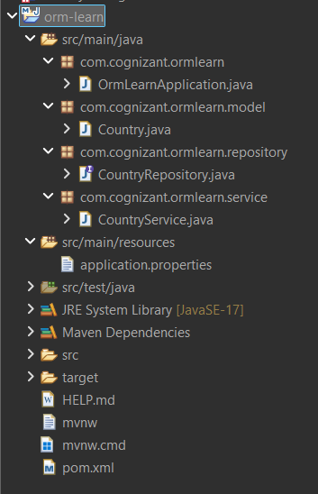

application.properties
logging.level.org.springframework=info
logging.level.com.cognizant=debug
logging.level.org.hibernate.SQL=trace
logging.level.org.hibernate.type.descriptor.sql=trace
logging.pattern.console=%d{dd-MM-yy} %d{HH:mm:ss.SSS} %-20.20thread %5p %-25.25logger{25} %25M %4L %m%n
spring.datasource.driver-class-name=com.mysql.cj.jdbc.Driver
spring.datasource.url=jdbc:mysql://127.0.0.1:3306/ormlearn
spring.datasource.username=root
spring.datasource.password=*********
spring.jpa.hibernate.ddl-auto=validate
spring.jpa.properties.hibernate.dialect=org.hibernate.dialect.MySQLDialect

Country.java
package com.cognizant.ormlearn.model;
import jakarta.persistence.*;
@Entity
@Table(name="country")
public class Country {
@Id
@Column(name="co_code")
private String code;
@Column(name="co_name")
private String name;
public Country(){}
public Country(String code,String name){
this.code=code;
this.name=name;
}
public String getCode(){ return code; }
public void setCode(String code){ this.code=code; }
public String getName(){ return name; }
public void setName(String name){ this.name=name; }
@Override
public String toString(){
return "Country [code="+code+", name="+name+"]";
}
}

CountryRepository.java
package com.cognizant.ormlearn.repository;
import org.springframework.data.jpa.repository.JpaRepository;
import org.springframework.stereotype.Repository;
import com.cognizant.ormlearn.model.Country;
@Repository
public interface CountryRepository extends JpaRepository<Country,String>{
}

CountryService.java
package com.cognizant.ormlearn.service;
import java.util.List;
import org.springframework.beans.factory.annotation.Autowired;
import org.springframework.stereotype.Service;
import org.springframework.transaction.annotation.Transactional;
import com.cognizant.ormlearn.model.Country;
import com.cognizant.ormlearn.repository.CountryRepository;
@Service
public class CountryService {
@Autowired
private CountryRepository countryRepository;
@Transactional
public List<Country> getAllCountries(){
return countryRepository.findAll();
}
}

OrmLearnApplication.java
package com.cognizant.ormlearn;
import java.util.List;
import org.slf4j.Logger;
import org.slf4j.LoggerFactory;
import org.springframework.boot.SpringApplication;
import org.springframework.boot.autoconfigure.SpringBootApplication;
import org.springframework.context.ApplicationContext;
import com.cognizant.ormlearn.model.Country;
import com.cognizant.ormlearn.service.CountryService;
@SpringBootApplication
public class OrmLearnApplication {
private static final Logger LOGGER=LoggerFactory.getLogger(OrmLearnApplication.class);
private static CountryService countryService;
public static void main(String[] args){
ApplicationContext context=SpringApplication.run(OrmLearnApplication.class,args);
countryService=context.getBean(CountryService.class);
LOGGER.info("Inside main");
testGetAllCountries();
}
private static void testGetAllCountries(){
LOGGER.info("Start");
List<Country> countries=countryService.getAllCountries();
LOGGER.debug("countries={}",countries);
LOGGER.info("End");
}
}

Console Output
